1. Provide a screenshot to show that you have successfully created the MBTANetwork network.



1. Provide a screenshot to show that you have successfully opened the mysqlDocker folder.

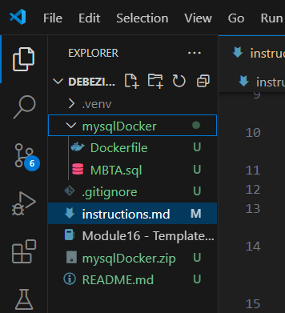

* 1. Provide a screenshot to show that you have successfully opened the MBTA.sql file.

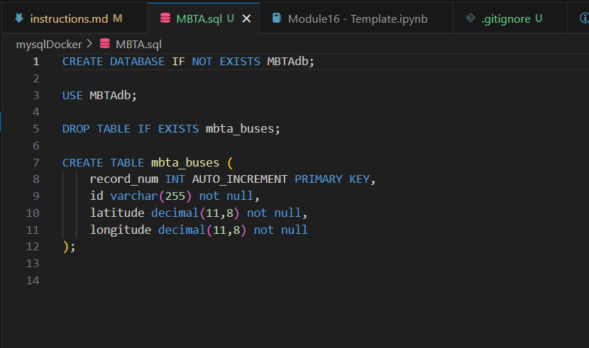

* 1. For this step, you will provide two screenshots. The first screenshot should show that you have successfully run the provided code in a Jupyter Notebook. The second screenshot should show that you have successfully added at least five additional fields to the mbta_buses table.

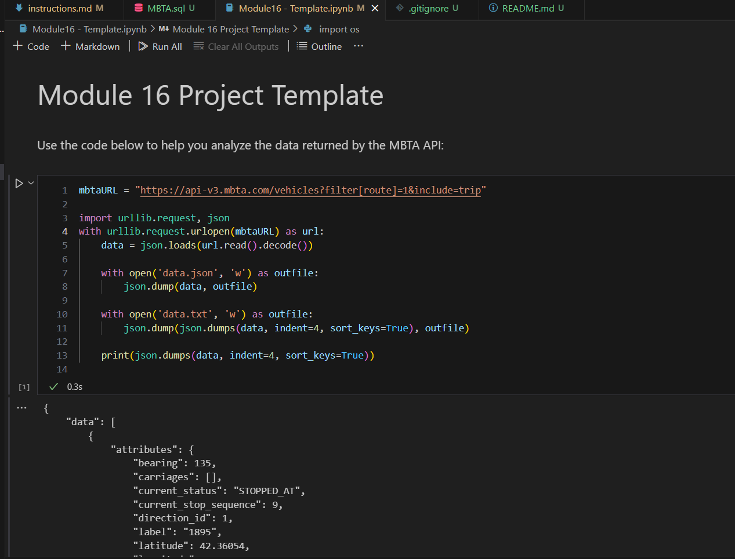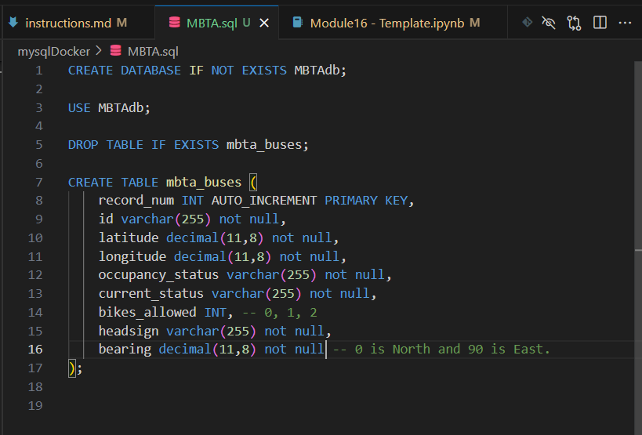

* 1. Provide a screenshot to show that you have successfully created the mysqlmbtamasterimg Docker *image*.

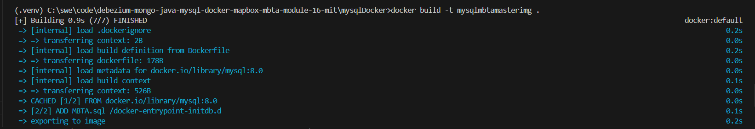

* 1. Provide a screenshot to show that you have successfully created the mysqlserver Docker *container*.



1. Provide a screenshot to show that you have successfully created the some-mongo Docker *container*.



1. 1. Provide a screenshot to show that you have successfully opened the Module16ProjectFlask.zip folder in VS Code.

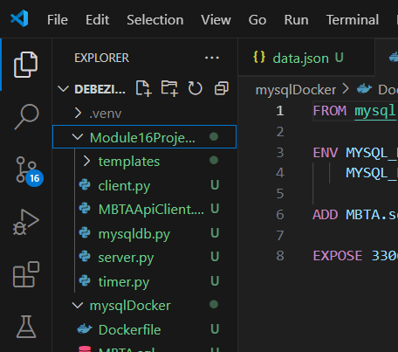

* 1. Provide a screenshot to show that you have successfully modified the mysqldb.py file.

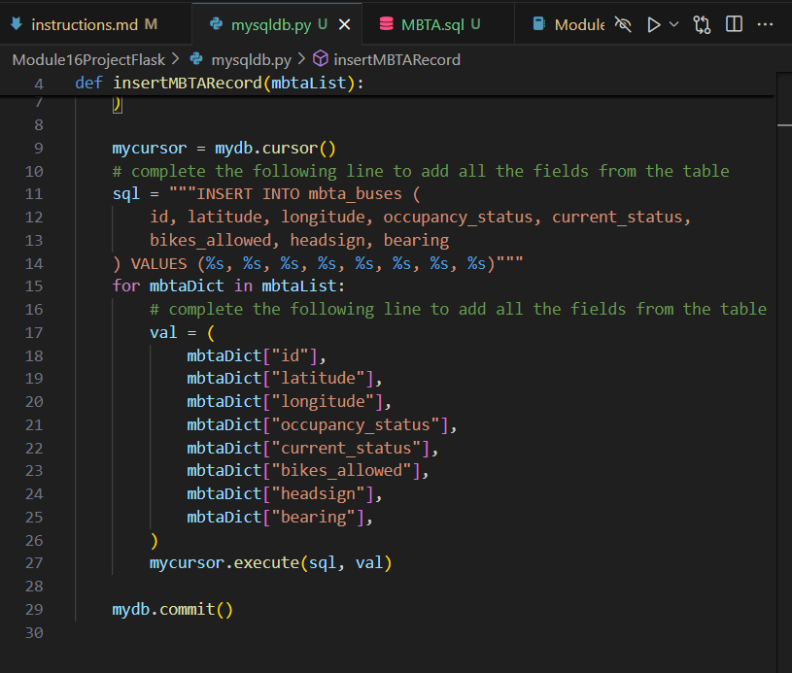

* 1. Provide a screenshot to show that you have successfully modified the MBTAApiClient.py file.

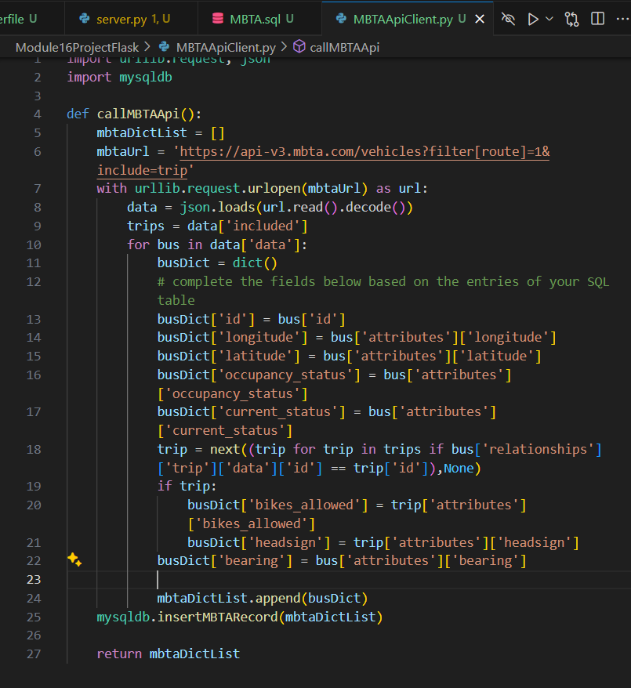

* 1. Provide a screenshot to show that you have successfully added your Mapbox access *token* in the index.html file.

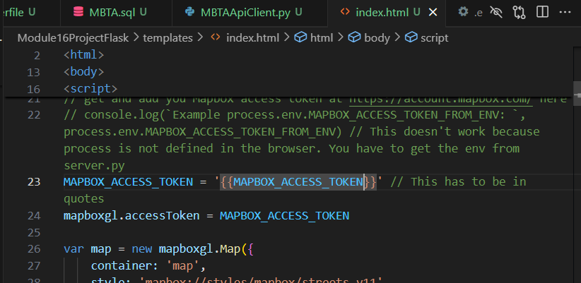

* 1. Provide a screenshot to show that you have successfully initialized the buses *list* in the server.py file.

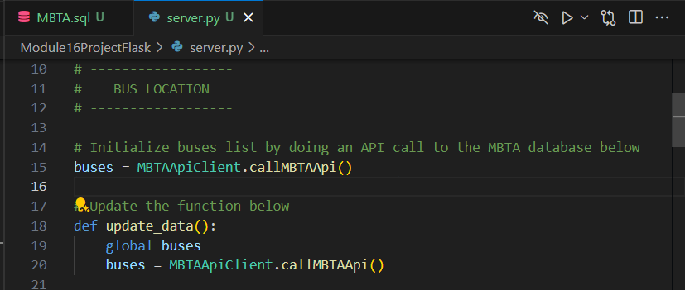

* 1. Provide a screenshot to show that you have successfully run the server.py file in VS Code.

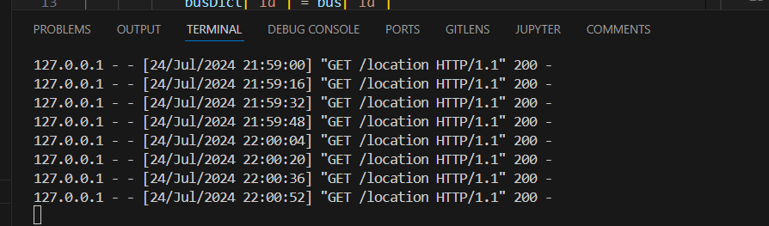

* 1. Provide a screenshot to show that you have successfully navigated to localhost:3000.

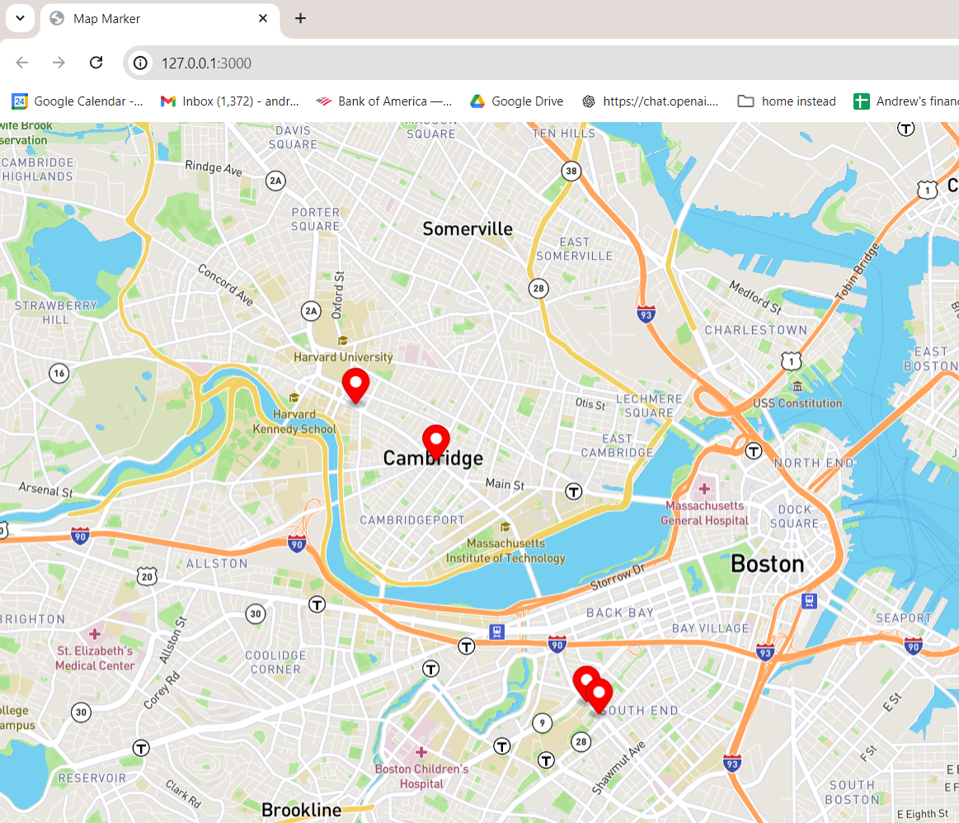

1. 1. Provide a screenshot to show that you have successfully opened the DebeziumCDC.zip folder in VS Code.

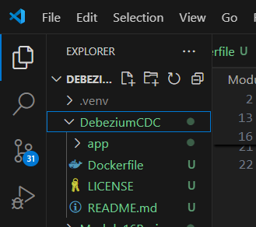

* 1. Provide a screenshot to show that you have successfully created the debeziummodule16 Docker *image*.

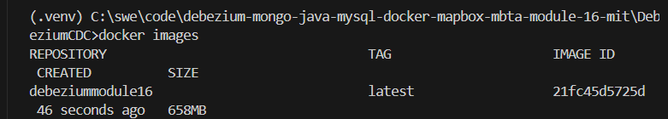

* 1. Provide a screenshot to show that you have successfully created the Docker *container* and associated it with the MBTANetwork network.

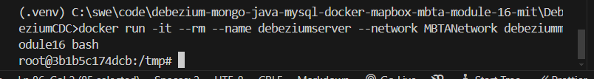

* 1. Provide a screenshot to show that you have successfully installed the nano text editor in your shell.

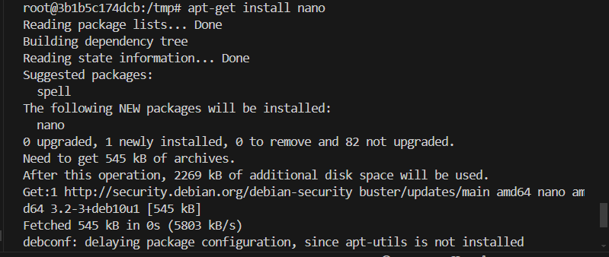

* 1. Provide a screenshot to show that you have successfully modified the MongoDB.java *class*.

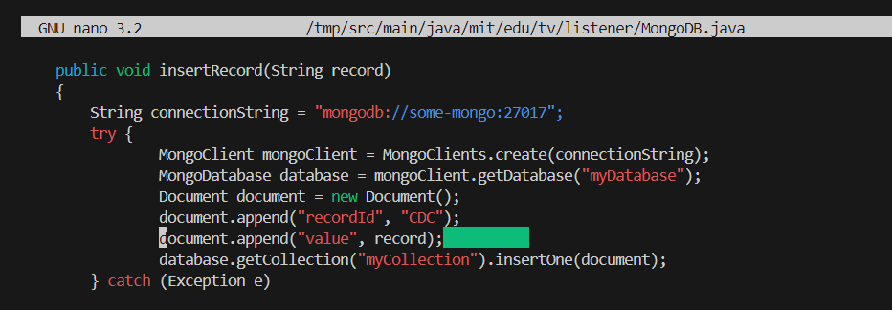

* 1. Provide a screenshot to show that you have successfully modified the handleChangeEvent *method*.

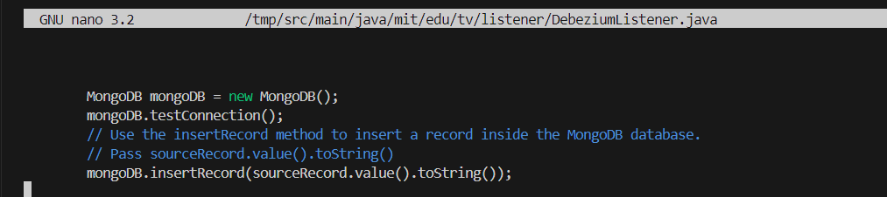

* 1. Provide a screenshot to show that you have successfully run the Maven SpringBoot application.

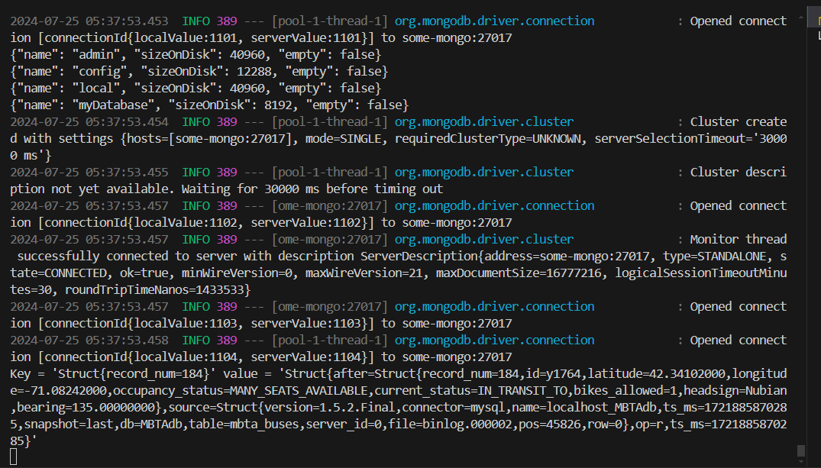

1. 1. Provide a screenshot of your Docker desktop to show the javamaven *container* running.



* 1. Provide a screenshot to show that you successfully navigated to the *directory* and listed the files.



* 1. Provide a screenshot to show that you successfully created the ReadCDC.java file and copied the code.

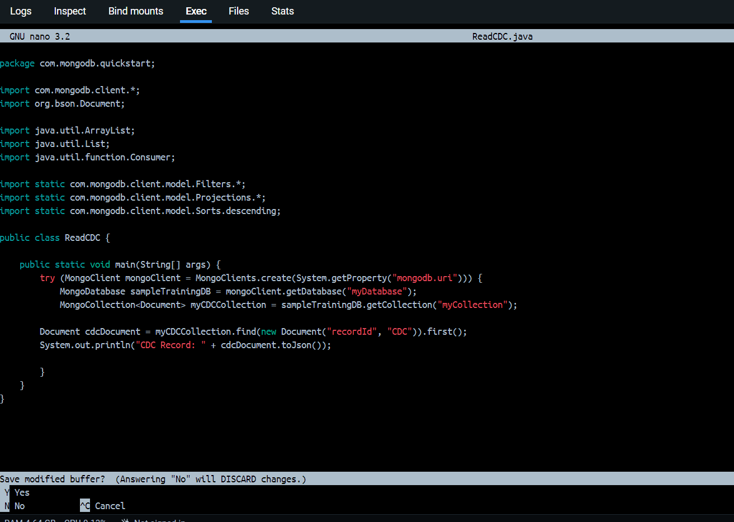

* 1. Provide a screenshot to show the results of the bash command to execute the ReadCDC.java *class*.

